

**The World’s First**

**Purpose Activation Survey**™

**To Measure Purpose Systemically**

The **Purpose Activation Survey**™ measures the core attributes of a Purpose Centered organization, an organization where Purpose is embedded into the entire organization and lived by all its employees and stakeholders.

The **Purpose Activation Survey**™ provides company executives, leaders and teams with a clear picture of the organization’s current state of Purpose. It helps answer key questions such as:

* Is Purpose truly embedded throughout your Company?
* Are Leaders “Leading for Purpose”?
* Are we activating Purpose in Employees and Teams?
* Are you connecting Purpose to your Customers? Shareholders? Other Key Stakeholders?
* Are we leveraging our Purpose to attract the best talent?
* Does every Leader and Employee see the benefits that Purpose provides for your business?

The **Purpose Activation Survey**™ is a new method to assess Purpose holistically and systemically across the organization. The survey can be administered across the entire organization or within selected groups. The survey report provides organizational leaders and teams with scores on each attribute of a Purpose Fit Organization, to help them define areas of Purpose strength and opportunities to develop. Reports can be generated at the organizational, regional, functional and team levels to help customize action plans across levels and groups.

**Does your Company want to lead with true Purpose and embed it throughout the company?**

**Are you looking for ways how to lead with Purpose most effectively?**

Then you are ready to take the **Purpose Activation Survey**™ to understand your company’s current Purpose fitness and find opportunities where you can improve.

**What is Purpose?**

In our definition, Purpose is the Why, the reason your company or brand exists, it gives meaning, and it defines the role of your business in solving societal problems and building a better world.

By Purpose we mean an aspirational reason for being that is larger than profits and focuses on creating a better sustainable world with positive impact for all stakeholders with respect for people and planet.

This aspirational reason for being goes beyond commercial and operational goals: it is a bigger ambition to make a positive difference in the world for all the stakeholders your business touches, for example for your employees, your customers, community and the planet.

**Purpose has Multiple Benefits!**

The benefits of leading a business with Purpose are numerous. Employee engagement is a clear business benefit to having a solid purpose. If employees feel they are working towards a good cause, it can increase their productivity by up to 30 percent, according to a study by the Center for Economic Studies. Organizations that have a clearly defined purpose aligned with a strategic plan outperform those who do not, according to a study by Bain and Company.

Although 90% of executives said their company understands the importance of purpose, only 46% said it informs their strategic and operational decision-making. Purpose is a powerful though underutilized tool.

* 89% of executives say a strong sense of collective purpose drives employee satisfaction
* 84% say it can affect an organization’s ability to transform
* 80% say it helps increase customer loyalty

However, only a minority said their company currently runs in a purpose-driven way. (HBR, 2015)

**Here is the Problem - Most Companies are Sub-Optimizing the Benefits of Purpose**

Companies and brands with purpose can make a bigger difference in the world, but only if they use their Purpose to transform their business models to become more sustainable, solve societal problems, and create positive impact for all its stakeholders inclusively. They need to go beyond intentions and words to show how purpose is really activated and embedded into all the areas of the organizational infrastructure, and how these actions translate into positive impact for the larger society.

A majority of companies have yet to embed a shared sense of purpose throughout their organizations that would allow them to see the benefits. The barriers include short-term shareholder pressure, systems and infrastructure that are not aligned with long-term purpose, and the lack of performance targets and incentives aligned with purpose. (HBR, 2015)

To maximize the benefit of purpose, it requires 100% integration and embedding it into your organization. We can help you identify your Purpose Focus Areas to improve your Organizational Purpose Leadership and Effectiveness.

**We developed the Purpose Activation Survey**™ **to provide you with a holistic assessment of Purpose in your organization and guides your efforts to activate and embed Purpose across your company**

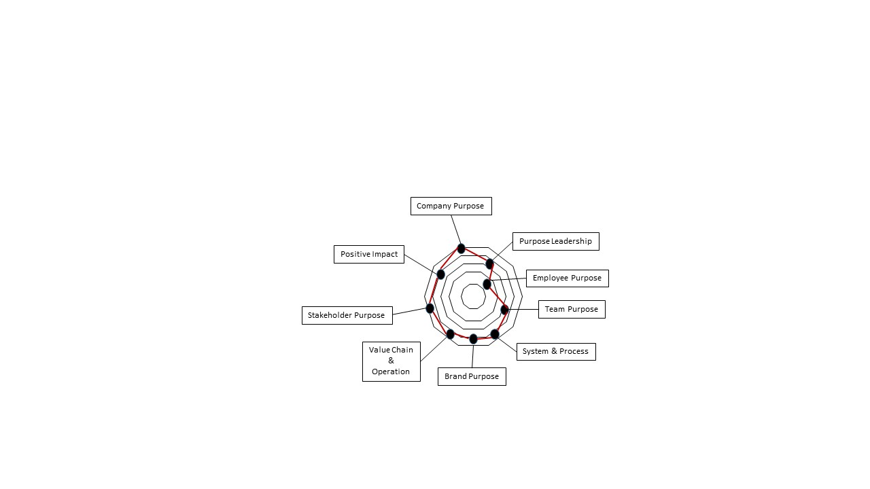

**The Purpose Activation Survey**™ **measures Purpose Effectiveness across 9 areas** to graphically represent your company’s purpose across the organization based on **Purpose,**

**Purpose Leadership, Employee Purpose**

**Team Purpose, Purpose wired into Systems & Processes, Brand Purpose, Purpose integration into Value Chain & Operations, Stakeholder Purpose and Positive Impact.**

***Sample Diagram showing Purpose Effectiveness***

**Your Company’s Purpose Leadership Results:**

* **Score**: based on the survey you complete you will receive a Purpose Effectiveness Score.
* **Purpose Organizational Type**: the score identifies your Company’s Purpose Leadership Type.
* **Improvement areas:** you will receive insights into your Purpose Gaps and Opportunities and receive actionable recommendations on how to improve your Purpose Effectiveness.

**Are you ready to seize the benefits the Purpose Activation Survey**™ **can offer your Company?**

Then be part of the first group of Companies that will run the Purpose Activation Survey™in their organizations and become one of the first movers in truly and holistically leading and activating Purpose in your organization!